DESIGN TASK FOR ECA5604 5G/6G COMMUNIACTIONS – SLOT A

DESIGN TASK1: Design a Cloud Radio Access Network model for dense urban deployment.
AIM : To design and simulate a Cloud Radio Access Network (C-RAN) model for dense urban deployment and analyze its throughput, latency, and resource utilization under varying user loads.
PROGRAM:
figure('Name','C-RAN Performance Analysis','NumberTitle','off');
subplot(2,2,1)
plot(users,throughput,'b-o','LineWidth',2);
grid on;
xlabel('Number of Users');
ylabel('Throughput (Gbps)');
title('Throughput vs Users');
subplot(2,2,2)
plot(users,latency,'r-*','LineWidth',2);
grid on;
xlabel('Number of Users');
ylabel('Latency (ms)');
title('Latency vs Users');
subplot(2,2,3)
plot(users,resourceUtil,'k-s','LineWidth',2);
grid on;
xlabel('Number of Users');
ylabel('Resource Utilization (%)');
title('Resource Utilization');
subplot(2,2,4)
yyaxis left
plot(users,throughput,'b','LineWidth',2)
ylabel('Throughput (Gbps)')
yyaxis right
plot(users,latency,'r','LineWidth',2)
ylabel('Latency (ms)')
xlabel('Number of Users')
title('Combined Performance')
grid on
legend('Throughput','Latency','Location','northwest')
sgtitle('Cloud Radio Access Network (C-RAN) Performance Analysis');
OUTPUT :
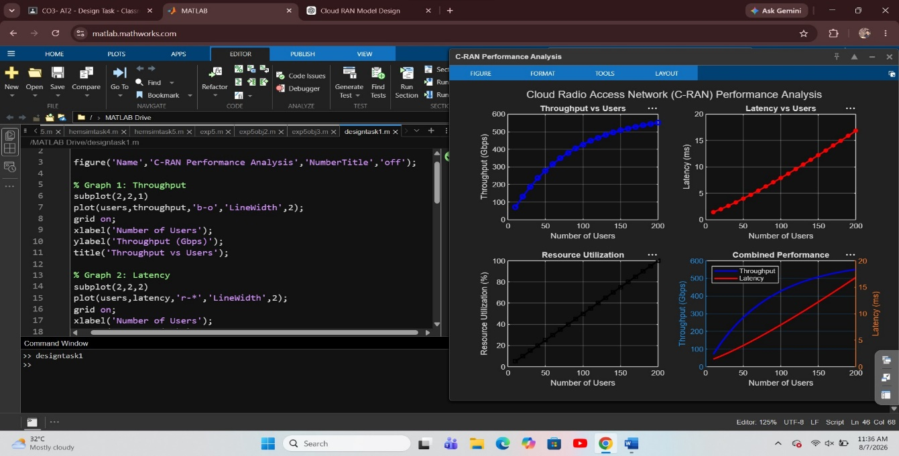Result: The C-RAN simulation successfully demonstrated the network performance for different numbers of users. The results show that throughput.
DESIGN TASK2: Develop a functional split model between centralized and distributed radio units.
AIM : To develop and simulate a functional split model between centralized and distributed radio units and analyze bandwidth, delay, and processing distribution.
PROGRAM:
clc;
clear;
close all;
split = 1:8;
fronthaul = [100 85 70 55 45 35 25 18];
processingCU = [20 28 38 50 62 72 82 92];
processingDU = 100 - processingCU;
delay = [0.8 1.0 1.2 1.6 2.1 2.7 3.3 4.0];
figure('Name','Functional Split Model Analysis','NumberTitle','off');
subplot(2,1,1)
yyaxis left
plot(split,fronthaul,'b-o','LineWidth',2)
ylabel('Bandwidth (Gbps)')
yyaxis right
plot(split,delay,'r-*','LineWidth',2)
ylabel('Delay (ms)')
grid on
xlabel('Functional Split Option')
title('Bandwidth and Delay Comparison')
legend('Bandwidth','Delay','Location','northwest')
subplot(2,1,2)
plot(split,processingCU,'b-o','LineWidth',2)
hold on
plot(split,processingDU,'r-s','LineWidth',2)
grid on
xlabel('Functional Split Option')
ylabel('Processing Load (%)')
title('Processing Distribution')
legend('Central Unit','Distributed Unit','Location','best')
sgtitle('Functional Split Model Between Centralized and Distributed Radio Units');
OUTPUT: 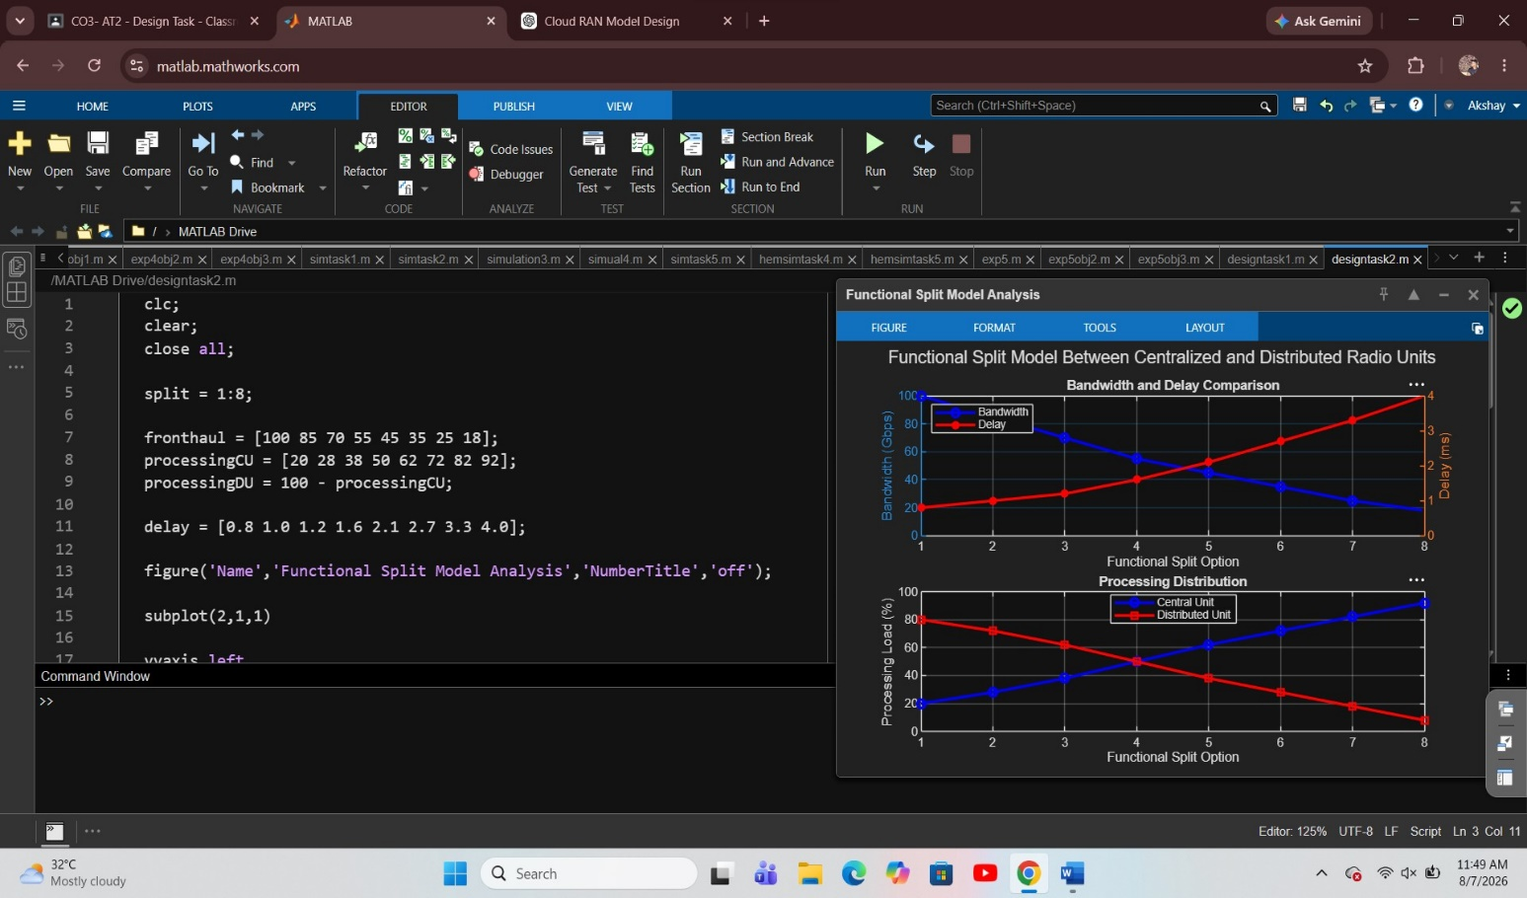
RESULT: The simulation shows that different functional split options affect fronthaul bandwidth, processing load distribution, and network delay, illustrating the trade-offs between centralized and distributed architectures.

